1. *FTP servers are the piece of software that allows you to create a FTP connection between your local computer and a web server.*
2. *Pro FTPD is a FTP server for Unix/Linux servers, very configurable and very effective, it is free & open-sourced, released under the GPL license****.***

***Now install Pro FTPD***

*apt-get update*

*apt-get install proftpd*

***Open file and configure ProFTPD Server***

*vi /etc/proftpd/proftpd.conf*

1. **Server Name**: Make it your default server name.
2. **UseIPV6:** You may switch it to “Off“, if you don’t use it.
3. **Default Root** : Uncomment this line to restrict users with their home folders.
4. **Require valid Shell**: Uncomment this line and make it “On” to enable logging in for users, even for those who doesn’t have a valid shell in /etc/shells to log in.
5. **Auth Order**: Uncomment the line to enable the using of local passwords.
6. **Port**: This line defines the default port for the FTP server, it is 21 by default. If you want, you can define any custom port here.

*service proftpd restart*

***create a FTP users***

*useradd -m deepak*

*passwd deepak*

***Here m is used for create home directory***

***If you have many users first create group and put users in the group.***

*groupadd pankaj*

*useradd -m deepak rahul*

*usermod -G sysadmin hp dell lenovo*

*Now create a file named deep inside user deep*

*touch /home/deepak/deep*

***Now mention user in configuration file;***

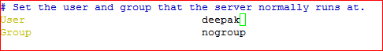

service proftpd restart

***Now go to the addresses on the browser, Enter user name and the password.***

*ftp://192.168.72.80*

***And you can access with WinScp;***

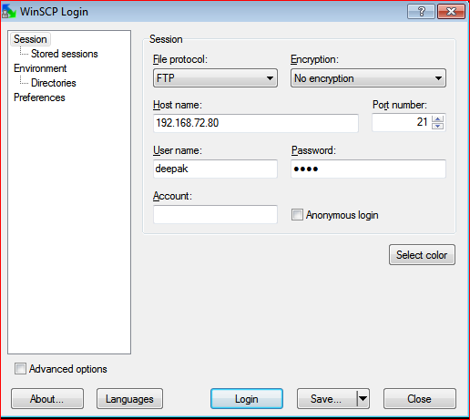

*After login it will show look like below.......;;;;;;*

